

Name : M Musa

Reg No : 41557

Submitted to : Mam Faiza Ali

Date : 29/10/26

Lab #2

GetHubLink: https://github.com/malikmusa044

Python Practice:
AI Applications
Two AI tools were explored: Google Lens (image recognition) and Claude (a chatbot). The table records the input, output, likely AI technique and one limitation for each.

 | Google Lens | Claude (chatbot)
Input | An image of an object, uploaded from the gallery. | A natural-language text prompt.
Output | The name of the object extracted and translatable text. | Generated text: Answers, explanations, summaries, or code.
AI technique | Computer vision using deep learning (convolutional neural networks) for image classification and object detection, plus OCR for text. | Large language model based on the transformer architecture (natural language processing trained on large text data).
Limitation | Accuracy drops blurry, poorly lit, partly hidden or uncommon objects, and it returns visually similar but wrong matches. | Produces confident but incorrect statements (hallucinations) and may not know very recent events unless it searches the web, so its answers must be verified.

Task 2: PEAS Description and Environment Properties:
For each agent, the PEAS description is given first, followed by the classification of the environment using six properties: observable, agents, deterministic, episodic, static and discrete.

Chess-playing program with a clock:

PEAS | Description
Performance measure | Win/draw/loss result; making moves within the time limit; quality of play
Environment | Chessboard with pieces, the opponent, the game clock
Actuators | Output of moves (moving pieces), resigning, claiming a draw
Sensors | Current board position, the opponent's last move, clock reading

Property | Classification | Justification
Observable | Fully observable | The whole board and the clock are visible to the agent.
Agents | Multi-agent (competitive) | The opponent actively tries to win.
Deterministic | Deterministic | A move always has a certain outcome; there is no chance element.
Episodic | Sequential | Each move affects all later positions.
Static | Semi-dynamic | The board does not change while thinking, but the clock keeps running.
Discrete | Discrete | Finite squares, pieces and legal moves.

Online English tutor:

PEAS | Description
Performance measure | Improvement in the student's test scores; engagement; lesson completion
Environment | The student, lesson material, exercises, the internet connection
Actuators | Displaying exercises and explanations, giving feedback and corrections, speech output
Sensors | Student's typed or spoken answers, response time, quiz results

Property | Classification | Justification
Observable | Partially observable | The tutor sees only answers, not what the student really understands.
Agents | Multi-agent | The student is another agent whose behaviour affects the outcome.
Deterministic | Stochastic | Student responses and progress are unpredictable.
Episodic | Sequential | Current feedback affects what the student learns next.
Static | Dynamic | The student's knowledge and state change while the tutor decides.
Discrete | Discrete | A finite set of exercises, answers and feedback messages.

Drone delivering parcels across Islamabad:

PEAS | Description
Performance measure | Parcels delivered on time and undamaged; safety; low battery use; no-fly zone compliance
Environment | Islamabad airspace, buildings, weather, other aircraft and birds, no-fly zones, customers
Actuators | Rotors/motors, parcel release mechanism, radio link
Sensors | GPS, camera, lidar/obstacle sensors, altimeter, wind and battery sensors

Property | Classification | Justification
Observable | Partially observable | Sensors have limited range; the drone cannot see every obstacle or weather change.
Agents | Multi-agent | Other aircraft, drones, birds and people share the airspace.
Deterministic | Stochastic | Wind gusts, weather and GPS error make outcomes uncertain.
Episodic | Sequential | Each flight decision affects battery, position and later decisions.
Static | Dynamic | Traffic and weather change while the drone is moving.

Discrete | Continuous | Position, speed, altitude and time are continuous values.

Task 3:
Random Agent vs Reflex Agent
The vacuum-cleaner reflex agent was modified into a random agent that selects an action from {Left, Right, Suck} at every step. Both agents were run for 20 steps on 10 random initial states, and their average performance scores were compared.

Setup
  - Environment: two squares, A and B, each Clean or Dirty; the agent starts in A or B.
  - Performance measure: +10 for cleaning a dirty square, −1 for every move (Left or Right), 0 for Suck on a clean square and for NoOp.
  - Each run lasts 20 steps. The 10 initial states (dirt status of A and B, and starting location) were generated randomly with random.seed(1) so results are repeatable. Both agents start from the same 10 states.

Code:
import random

def reflex_agent(percept): location, status = percept if status == "Dirty":
return "Suck"
return "Right" if location == "A" else "Left"

def random_agent(percept):
return random.choice(["Left", "Right", "Suck"])

def make_model_based_agent(): cleaned = set()
def agent(percept):
location, status = percept

cleaned.add(location) if status == "Dirty": return "Suck"
if cleaned == {"A", "B"}: return "NoOp"
return "Right" if location == "A" else "Left" return agent

def run(agent, world, location, steps=20, verbose=False): world = dict(world)
score = 0
for step in range(steps):
action = agent((location, world[location])) if verbose:
print(f"Step {step:2}: at {location}, sees {world[location]:5} ->
{action:5} | score {score}") if action == "Suck":
if world[location] == "Dirty": score += 10
world[location] = "Clean" elif action == "Right":
location = "B"; score -= 1 elif action == "Left":
location = "A"; score -= 1 return score

random.seed(1)
states = [({"A": random.choice(["Clean", "Dirty"]),
"B": random.choice(["Clean", "Dirty"])},
random.choice(["A", "B"])) for _ in range(10)]

print("=== TASK 3: reflex vs random ===") tr = tn = 0
for i, (w, loc) in enumerate(states, 1): r = run(reflex_agent, w, loc)
n = run(random_agent, w, loc) tr += r; tn += n
print(f"State {i:2}: A={w['A']:5} B={w['B']:5} start={loc} | reflex {r:3} | random {n:3}")
print(f"Average reflex: {tr/10}") print(f"Average random: {tn/10}")

print("\n=== TASK 4: model-based ===")

w, loc = {"A": "Dirty", "B": "Dirty"}, "A" print("Trace (A Dirty, B Dirty, start A):")
run(make_model_based_agent(), w, loc, steps=6, verbose=True) tm = tr2 = 0
for w, loc in states:
tm += run(make_model_based_agent(), w, loc) tr2 += run(reflex_agent, w, loc)
print(f"\nAverage reflex: {tr2/10}") print(f"Average model-based: {tm/10}")

Screenshot:
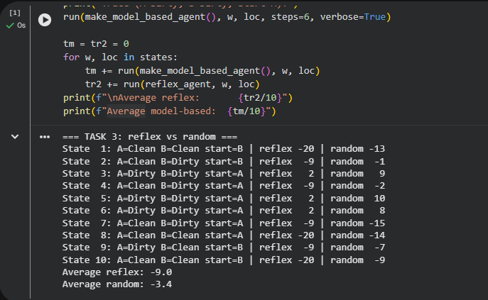

Analysis
The random agent scored higher on average (-3.4) than the reflex agent (-G.0). The reflex agent makes the right decision at every step: it sucks when the square is dirty and moves otherwise. However, it has no memory, so it cannot know that the job is finished. After both squares are clean it keeps moving between A and B and loses 1 point on every step. In the states where both squares started clean (states 1, 8 and 10) it scored −20 for 20 pointless moves.
The random agent moves only about two thirds of the time, because Suck on a clean square costs nothing, so it loses fewer points overall. It is not reliable, though: it may leave

dirt behind, as in state 7 where it scored −15. The comparison shows that with a movement penalty, an agent that cannot tell when to stop can perform worse than a random one. The ranking also depends on the performance measure that is used.

Task 4:
Model-Based Agent
The reflex agent was extended with an internal model: a set that remembers which locations have been cleaned. When the set contains both A and B, the agent performs NoOp and stops. The run function treats NoOp as an action that changes nothing and costs nothing.

Code:
import random

def reflex_agent(percept): location, status = percept if status == "Dirty":
return "Suck"
return "Right" if location == "A" else "Left"

def random_agent(percept):
return random.choice(["Left", "Right", "Suck"])

def make_model_based_agent(): cleaned = set()
def agent(percept):
location, status = percept cleaned.add(location)
if status == "Dirty": return "Suck"
if cleaned == {"A", "B"}: return "NoOp"
return "Right" if location == "A" else "Left" return agent

def run(agent, world, location, steps=20, verbose=False): world = dict(world)
score = 0
for step in range(steps):

action = agent((location, world[location])) if verbose:
print(f"Step {step:2}: at {location}, sees {world[location]:5} ->
{action:5} | score {score}") if action == "Suck":
if world[location] == "Dirty": score += 10
world[location] = "Clean" elif action == "Right":
location = "B"; score -= 1 elif action == "Left":
location = "A"; score -= 1 return score

random.seed(1)
states = [({"A": random.choice(["Clean", "Dirty"]),
"B": random.choice(["Clean", "Dirty"])},
random.choice(["A", "B"])) for _ in range(10)]

print("=== TASK 3: reflex vs random ===") tr = tn = 0
for i, (w, loc) in enumerate(states, 1): r = run(reflex_agent, w, loc)
n = run(random_agent, w, loc) tr += r; tn += n
print(f"State {i:2}: A={w['A']:5} B={w['B']:5} start={loc} | reflex {r:3} | random {n:3}")
print(f"Average reflex: {tr/10}") print(f"Average random: {tn/10}")

print("\n=== TASK 4: model-based ===")
w, loc = {"A": "Dirty", "B": "Dirty"}, "A" print("Trace (A Dirty, B Dirty, start A):")
run(make_model_based_agent(), w, loc, steps=6, verbose=True)

tm = tr2 = 0
for w, loc in states:
tm += run(make_model_based_agent(), w, loc) tr2 += run(reflex_agent, w, loc)
print(f"\nAverage reflex: {tr2/10}") print(f"Average model-based: {tm/10}")

Screenshot:
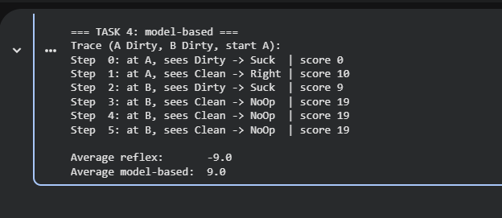

Comparison on the 10 initial states

State | Start (A / B / agent) | Reflex | Random | Model-based
1 | C / C / B | -20 | -13 | -1
2 | C / D / B | -9 | -1 | 9
3 | D / D / A | 2 | 9 | 19
4 | C / D / A | -9 | -2 | 9
5 | D / D / A | 2 | 10 | 19
6 | D / D / A | 2 | 8 | 19
7 | C / D / A | -9 | -15 | 9
8 | C / C / A | -20 | -14 | -1
G | D / C / B | -9 | -7 | 9
10 | C / C / B | -20 | -9 | -1
Average |  | -G.0 | -3.4 | G.0
C = Clean, D = Dirty.

Analysis
The model-based agent achieved the best average score (G.0). Because it remembers which locations it has handled, it stops as soon as both are known to be clean instead of wandering. With both squares dirty it scores 19 (two cleanings and one move). Even when both squares start clean it loses only 1 point, because it has no prior knowledge and must visit both squares once to confirm they are clean, whereas the reflex agent loses 20.
The limitation of this agent is that it assumes a clean square stays clean. If dirt could appear again later, the agent would never check again, so a different design would be needed for such an environment.

